Machine Learning Based Water Quality Monitoring System

Utkarsh Sinha(19BEC0463)
Electronics and Communication Engineering, VIT Vellore
Nithin Raja(19BML0066)
Electronics and Communication Engineering, VIT Vellore
Sree Lalitha P.V.S(19BEC0530)
Electronics and Communication Engineering,VIT Vellore

Abstract— Water quality is of much importance in our day to day lives. Prediction of water quality will help to reduce water pollution and guard our human health. An intelligent process of monitoring the quality of water automatically detects the condition of water through IoT by processing sensors data and instantly provides notification to water analyst, when the quality of water is abnormal. With the initiation of Machine to Machine Communication analysing and communicating the data becomes simple and efficient. This work has advanced an “Intelligent IoT based water quality monitoring system” pertaining to lakes is being used in rural areas. The structure uses pH, Turbidity and Conductivity sensors for determining the water quality parameters about hydrogen ion and total dissolved solvents in the water.
Results are stored in the cloud server and communicated to the water analyst through the personal computers for better knowledge and understanding of water quality.

Introduction
Water is one of the most valuable natural resources that humanity has been given. However, as a result of the rapid rise of industrial companies and the abundance of human activities, the poisoning of water resources has increased dramatically. To address the overhead difficulties, real-time water quality monitoring is required to detect any changes in water quality parameters and ensure that it is safe to consume. Water quality monitoring is crucial for determining whether or not we are making progress in cleaning up our rivers. It shows the health and composition of streams, rivers, and lakes in real time, as well as over the course of weeks, months, and years. The importance of monitoring changes in water quality cannot be overstated: clean, reliable water sources are essential for human health and livelihood. The US Safe Drinking Water Act establishes federal criteria for testing drinking water for pollutants such as bacteria and chemicals in order to protect human health. The device successfully aids in the screening of water quality parameters and the analysis of water quality over long distances without data loss, preventing life-threatening impacts on humans and animals.
Water quality prediction will aid in the reduction of pollution and the protection of human health. We will be constructing an "Intelligent IoT Based Water Quality Monitoring System" for lakes in rural regions as part of our project. For evaluating water quality characteristics such as hydrogen ions and total dissolved solvents in the water, the structure uses pH, turbidity, and conductivity sensors. For improved knowledge and comprehension of water quality, the results are saved in the cloud server and delivered to the water analyser via personal computers. This proposed model safeguards standard quality water for rural people using low prices embedded devices like Arduino Uno. An intelligent process of monitoring the quality of water automatically detects the condition of water through IoT by processing sensors data and instantly provides notification to water analysts, when the quality of water is abnormal.
Water quality can be decided by taking 5 parameters into account: pH, Sulphate, Conductivity, Hardness, Chloramines. Here we will use 5 parameters for testing the quality of water that is added in Arduino. The data will be sent from proteus to python script. From the python, the data will be sent to the machine learning cloud to check if the “water quality is potable or not”. The API outputs the information.
To begin, the sensors are submerged in water to detect the five parameters that are essential for the process. The sensors' outputs are then relayed to the Arduino UNO. The data is processed using Arduino. Compim is used to link Arduino to a virtual serial emulator, which transfers data from Arduino to the Python script. The python script sends the observed parameter values from Arduino to Machine Learning and then receives and displays the output from Machine Learning. Machine learning is a subclass of artificial intelligence (AI) that provides statistical tools to explore and analyse data. It is a prediction based on an experience system. First and foremost, it allows the computer to think without the need for human interpretation. It can expose to make future decisions with the use of prior data, referred to as training data. Various types of water, such as mud water, lemon water, saltwater, tap water, and drinking water, are used as preparatory sets. The fresh data sets that must be forecasted and have similar pH, conductivity, and turbidity values are placed in the same cluster. During the training period, all of the water quality data are clustered in such a way that each cluster in the network represents a certain type of water, such as mud water, lemon water, salt water, tap water, and drinking water.

LITERATURE REVIEW
In [1], L.Kuang discusses water quality monitoring using Wireless Sensor Networks (WSNs) in aquaculture water quality management. Dissolved oxygen (DO) is an important parameter in water quality monitoring, and its projection can help aquaculture producers make better decisions, reducing risk. Developing an appropriate prediction model, on the other hand, is difficult, and current DO prediction approaches disregard the need of researching DO content. This concept is based on an edge computing architecture in which data collection, processing, and dissolved oxygen prediction are distributed among sensor nodes, routing nodes, and servers, respectively. Sensing techniques and clustering operations are used in the data collection and processing phase. Meanwhile, an optimized extreme learning system is employed to forecast DO. On enormous water quality data, they tested the efficiency and accuracy of the suggested prediction approach in practical aquaculture.
Nur Aqilah talks about the Water management system used as an end-to-end process to produce a complete framework approach for the growth prediction of Harmful Algal Bloom (HAB) using rigorous predictive modelling of HAB to reduce water pollution. Previous studies have focused on the prediction aspect of the water monitoring system's deployment, necessitating sensor integration via the Internet of Things (IoT). In [2] , Nur Aqilah covers the entire process from start to finish, including sensor assembly and assimilation, data acquisition, and predictive modelling for future algae growth outbreak mitigation using data-driven approaches like machine learning, deep learning, and deep time series forecasting computational methods. In conclusion, this paper demonstrates that using time series with deep learning and selecting the appropriate features is considerably preferable than dealing with the issues of highly non-linear and dynamic algae ecological data.
Arunima Sambhuta discusses about the Water quality monitoring systems based on the Internet of Things (IoT) often use low-cost sensors with rapid reaction times. Soft sensing techniques are used to measure a few water quality indicators such as Chemical Oxygen Demand (COD), Biological Oxygen Demand (BOD), Chlorine (Cl), and Total Phosphorus. This research investigates a variety of Machine Learning (ML) models in order to select one model that recognizes the non-linearity of the dependency and determine a correlation between input and output parameters so as to develop a COD soft sensor. To anticipate COD in real-time, the nominated models are installed in the suggested IoT infrastructure. More than 16000 data samples from the river Ganga with ten different water quality metrics were collected and tested. The findings of a few of the finest performing machine learning algorithms, such as Multiple Linear Regression, Multilayer Perceptron, Support Vector Machine, Random Forest, and K-Nearest Neighbour, are compared in the work [3] (KNN). In terms of response time, the KNN technique proved to be the most efficient in the prediction of COD.
Chunxue Wu [4] targeted compounds like Polychlorinated Biphenyls (PCBs), Pesticides (PESTs), Polycyclic Aromatic Hydrocarbons (PAHs), etc… in the Great Lakes Integrated Atmospheric Deposition Network (IADN), which is a platform based on the IoT (Internet of Things) technology to collect environmental pollutants data. The main results of this article were 1) identifying the spatial and temporal trends of POPs (Persistent Organic Pollutants) in the air of the Great Lakes; 2) An appropriate data-driven intelligent model was constructed for the data at showing the concentrations will continue declining with slight fluctuations.
Sandro Carrara [5] examined the design and installation of a portable, mobile, cost-effective, and trustworthy water level management system. Two radio frequency (RF) transceivers and a transmitter were placed on the tank and sump at the site where the water quality was to be checked. RF transceivers are used to communicate with the internet server wirelessly. The device was fully configured for the user using a microcontroller unless the water in the bottle is drained or overflowing. An array of sensors was used to track various parameters like dissolved oxygen, tumbling, pH, temperature, and a variety of other parameters. Installation costs are reduced as it is a wireless system.
Within the perspective of instrumental restrictions, Shahadah Nurani Zulkifli [6] covers the evolution of water quality monitoring technologies for the detection of biological and chemical contaminants. The research focuses on the most up-to-date methodologies for water pollution detection applications.
Xiran Zhou tells that [7], chlorophyll is one of the most important markers for determining the canal system's water quality and suitability for drinking and irrigation. However, earlier research used medium-resolution remote sensing data (e.g., Landsat) to create state-of-the-art algorithms for water chlorophyll estimate, which has insufficient resolution to capture canals that are often thinner than one pixel in such data. For an effective inquiry on real-time water chlorophyll monitoring, high-resolution imageries covering the entire canal network may only comprise visible wavebands (i.e. red, green, and blue bands) or cost thousands of dollars. This letter details our efforts to discover and assess the scope of Planet data for determining the chlorophyll concentration in canal waters. The trials reveal that, while Planet can depict relative variations in water chlorophyll concentration, additional algorithms are still required for reliable findings in a canal system.
Mohammad Salah Uddin Chowdurya [8] developed a system for continuous river water quality monitoring in remote places using low-power, low-cost wireless sensor networks with excellent detection accuracy. In order to improve water quality, pH, conductivity, turbidity level, and other characteristics are analysed. Data collected by the author at the site is shown in a visual format on a server PC and compared to standard values using Spark streaming analysis via Spark MLlib, Deep learning neural network models, and the Belief Rule Based (BRB) system. The agent will receive an automated warning SMS message if the amount obtained exceeds the threshold value.
Monira Mukta [9] outlines an Internet of Things-based smart water quality monitoring (SWQM) system that enables for continuous monitoring of water conditions utilizing four physical parameters: temperature, pH, electric conductivity, and turbidity. Four sensors are separately connected to an Arduino-UNO to detect the water parameters. The sensor data is transferred to a desktop application based on the.NET framework, where it is compared to WHO standard values. Using a fast forest binary classifier to evaluate whether the test water sample is drinkable or not, the proposed SWQM system can successfully analyse the water parameters based on the observed results.
Amin Mohd. [10] focuses on Frequent water disruption in Malaysia which caused turbulence in daily lives and livelihood of thousands Malaysians. The water operators in Malaysia are facing serious challenges to ensure consumers have continuous access to clean water and to ensure a sustainable water future. River pollution in Malaysia had been identified to be one of the causes of water crisis in Malaysia. Hence, a continuous monitoring system utilizing the concept of Internet of Things had been proposed in this paper. Agile model is used due to its simplicity. The water's pH measurement, turbidity, temperature and flow can be measured and the reading will be sent to end-user. The sensors that detects the pH value, turbidity, temperature and flow measurement of a water sample will pass through the information to the Arduino, and the result will be shown on the mobile devices via an app called Blynk. This portable and comprehensive prototype is suitable to be used in Smart Cities where Wi-Fi signals is available as the transmission medium.

METHODOLOGY
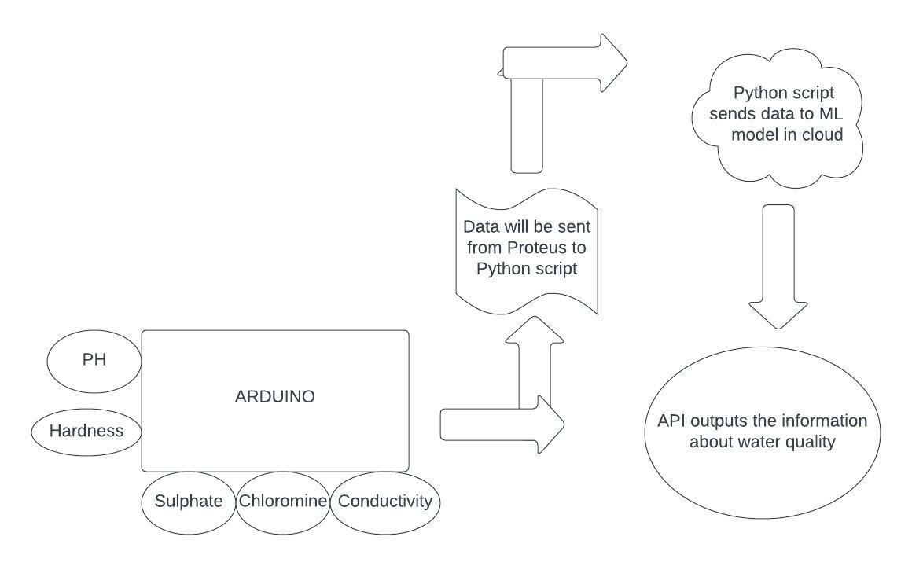
Fig.1: Block Diagram

Water quality can be decided by taking 5 parameters of water into account. They are; pH value: PH is an important parameter in evaluating the acid–base balance of water. WHO has recommended maximum permissible limit of pH from 6.5 to 8.5. The current investigation ranges were 6.52–6.83 which are in the range of WHO standards. Hardness: Hardness is mainly caused by calcium and magnesium salts. In general water with less than 60 ppm of calcium carbonate can be considered soft and water with 60-120 ppm Chloramines: Chlorine and chloramine are the major disinfectants used in public water systems. Chlorine levels up to 4 milligrams per litre (mg/L or 4 parts per million (ppm)) are considered safe in drinking water. Sulphates: It ranges from 3 to 30 mg/L in most freshwater supplies, although much higher concentrations (1000 mg/L) are found in some geographic locations. Turbidity: The turbidity of water depends on the quantity of solid matter present in the suspended state. The mean turbidity value obtained for Wondo Genet Campus (0.98 NTU) is lower than the WHO recommended value of 5.00 NTU.

WORKING
In this circuit we were using five sensors for detecting pH, hardness, sulphate, solids and turbidity of the water. The serial.begin( ) sets the baud rate for serial data communication. The baud rate signifies the data rate in bits per second. Here we’ve used 9600 bps (bits per second).
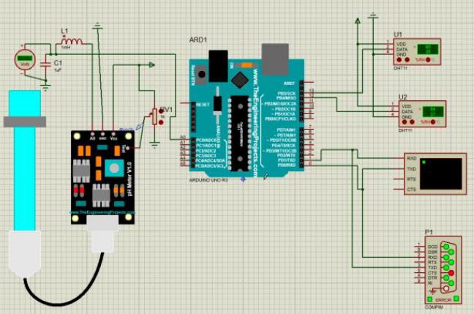
Fig. 2 : Circuit Diagram

RESULTS

The analysed results are shown in python script. After which the water is declared as portable or not and displayed in the hosted server

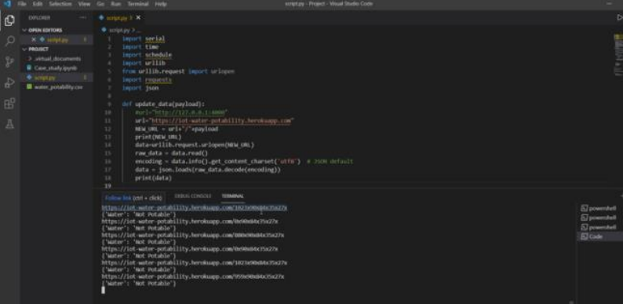

Fig. 3: VS Code Output to see water is potable or not

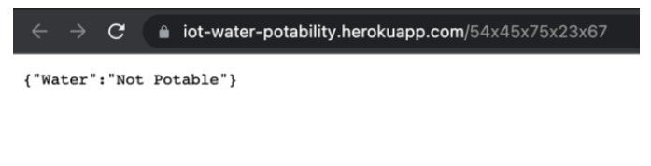
Fig. 4 : Cloud Server Output

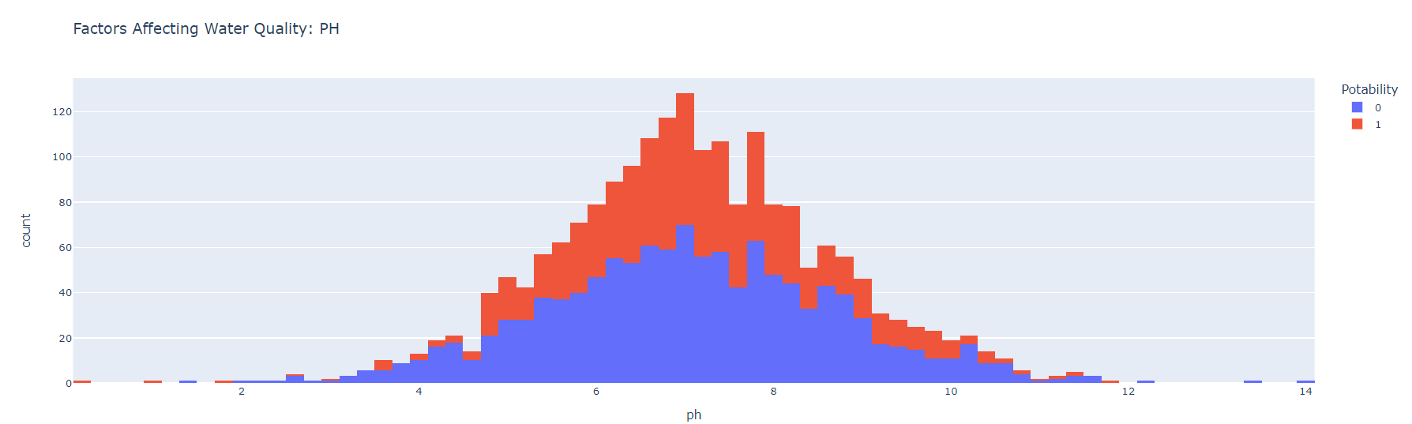

Fig. 5.1: pH vs Potability

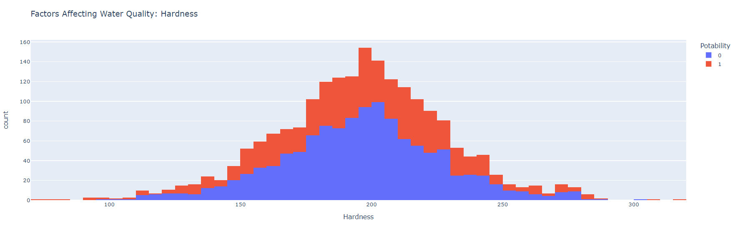 Fig. 5.2: Hardness vs Potability

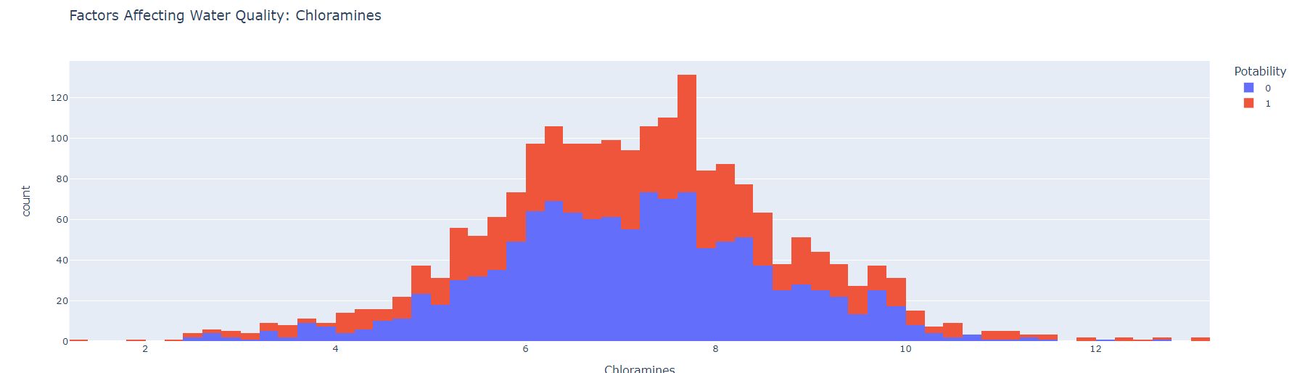

Fig. 5.3: Chloramine vs Potability
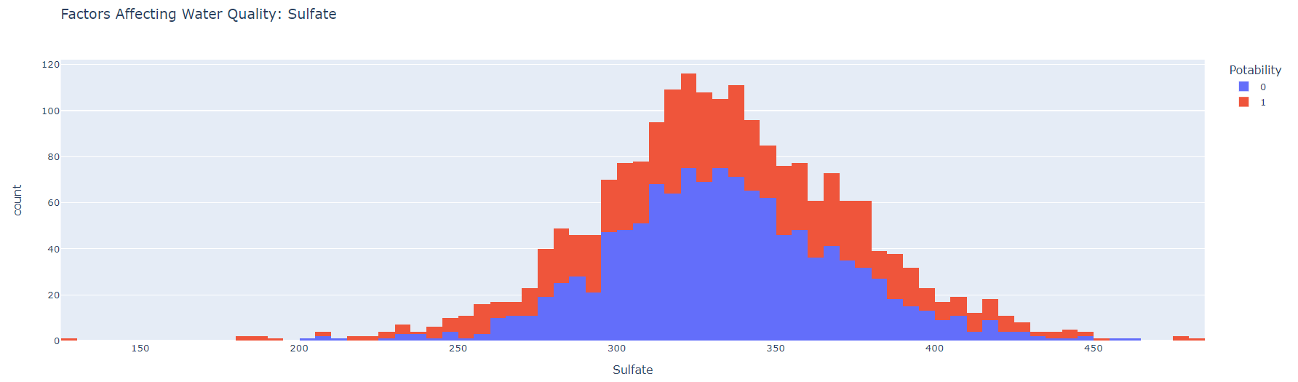

Fig. 5.4: Sulphates vs Potability
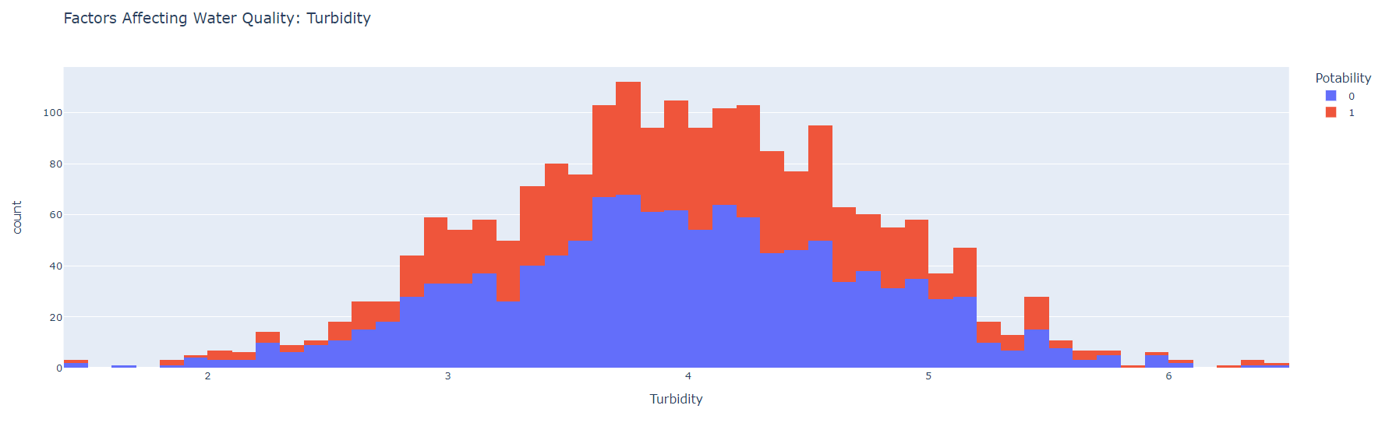
Fig. 5.5 Turbidity vs Potability

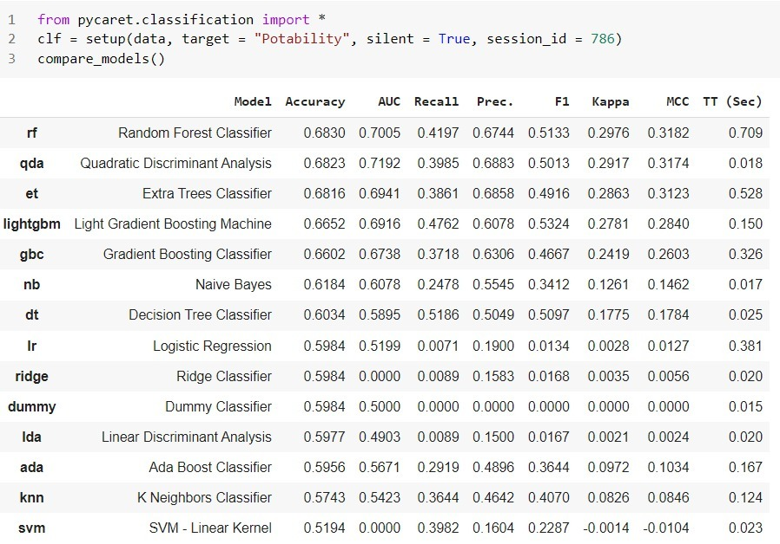

Fig. 6 : Detecting the best model to predict water quality

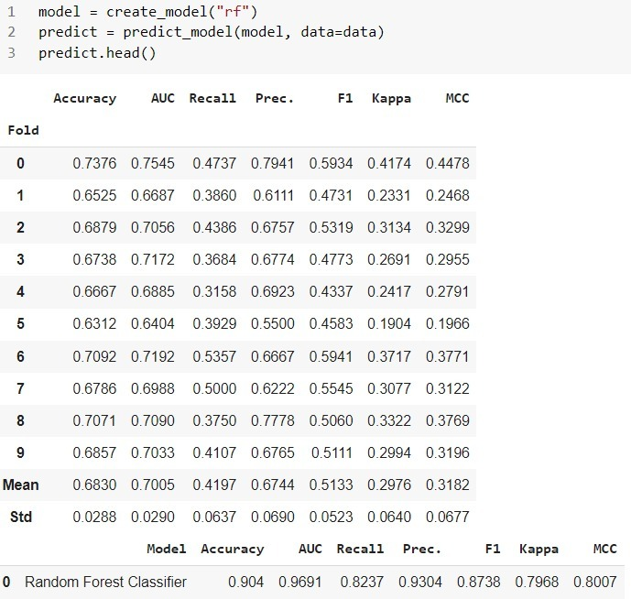

Fig.7 : The code decides the best model to predict Water Quality

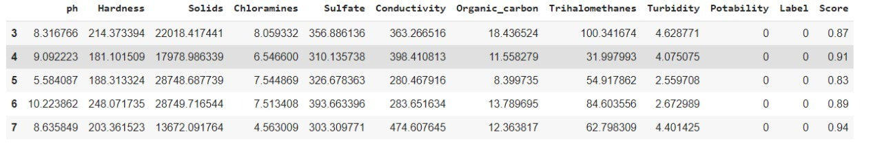

Fig. 8 : Final Output determining the potability and accuracy of prediction

Host ID: https://iot-water-potability.herokuapp.com/54x45x75x23x67

COMPARISON

In this section, we compare our results from the results that we referred to. We conclude that for our dataset Random Forest classification is the best performing machine learning model to find the potability of water. Then we train the model to predict the potability of water and its accuracy. On comparing our result to the previous results obtained by the author Liang Kaung in paper [1] , our models produces almost the same accuracy in detecting the potability of water along with the dissolved oxygen content of water , With Nur Aqilah’s model in paper [2] they use a hybrid model of rf classifier and LTSM model monitoring the coastal water quality with algae predictive modelling in the water body , also it results in a similar accuracy as ours. In paper [3] the authors Arunima and Chunxue have developed a COD monitoring system using edge intelligence while we have used cloud service to display output. In paper [4] the authors have analysed the organic pollutants content in the water body while we have used a local dataset for analysis. In [6] the authors have tried to detect the contaminants in water supply using sensors and actuators without using any machine learning. In [7] water chlorophyll estimation is done which detects the amount of chlorophyll in urban canal system.

CONCLUSION

Water quality monitoring system is an essential need today. Along these lines, the proposed framework has settled to an Intelligent constant IoT based Water Quality Monitoring framework which is taking parameters from water and telling whether the water is potable or not through cloud service. Then we are taking a sample with existing parameters, analysing the dependence of water quality on these parameters and allowing the ML model to decide water quality will be potable or not. In fig.4 the cloud server returns the output, whether the potable is potable or not. In fig.5.1 the pH values are analysed in the dataset. In fig. 5.2, we analyse the relation between hardness count and potability. In fig. 5.3 we compare the Chloramine content and its effect on water quality. In fig. 5.4 we have analysed the sulphates content and its effect on the water quality. In fig.5.5 we have compared the turbidity content of the water. Also, we are trying to analyse which ML model will be the best for any water quality dataset. The code can decide which model to use for predicting the water quality of that dataset. It compares different ML models and determines which will be the most accurate ML model to predict potability for the dataset. Ultimately, we train the derived model to predict water potability at any later amount of time.

References

[1] An Enhanced Extreme Learning Machine for Dissolved Oxygen Prediction in Wireless Sensor Network Authors: L. Kuang, P. Shi, C. Hua, B. Chen and H. Zhu, "An Enhanced Extreme Learning Machine for Dissolved Oxygen Prediction in Wireless Sensor Networks," in IEEE Access, vol. 8, pp. 198730-198739, 2020, DOI: 10.1109/ACCESS.2020.3033455.

[2] A Complete Proposed Framework for Coastal Water Quality Monitoring System With Algae Predictive Model, Authors: N. A. P. Rostam, N. H. A. H. Malim, R. Abdullah, A. L. Ahmad, B. S. Ooi and D. J. C. Chan, "A Complete Proposed Framework for Coastal Water Quality Monitoring System With Algae Predictive Model," in IEEE Access, vol. 9, pp. 108249-108265, 2021, doi: 10.1109/ACCESS.2021.3102044.

[3] Development of Chemical Oxygen on Demand (COD) Soft Sensor using Edge Intelligence
Authors: A. S. Patnaik, B. S. Patnaik, S. K. Udgata, and A. K. Panda, "Development of Chemical Oxygen on Demand (COD) Soft Sensor Using Edge Intelligence," in IEEE Sensors Journal, vol. 20, no. 24, pp. 14892-14902, 15 Dec.15, 2020, DOI: 10.1109/JSEN.2020.3010134.

[4] Design and Analysis of a Data-Driven Intelligent Model for Persistent Organic Pollutants in the Internet of Things Environments Authors: C. Wu, C. Wang, Q. Fan, Q. Wu, S. Xu, and N. N. Xiong, "Design and Analysis of a Data-Driven Intelligent Model for Persistent Organic Pollutants in the Internet of Things Environments," in IEEE Access, vol. 9, pp. 13451-13463, 2021

[5] Smart water quality monitoring system with cost-effective using IoT, Authors: Sathish Pasika Sai Teja Gandla in helicon Volume 6, Issue 7, July 2020

[6] Detection of contaminants in water supply: A review on state-of-the-art monitoring technologies and their applications Sensors and Actuators B: Chemical ,Volume 255, Part 3, February 2018, Authors: Syahidah Nurani Zulkifli, a Herlina Abdul Rahim, a and Woei-Jye Laub in Elsevier Public Health Emergency Collection.

[7] Water Chlorophyll Estimation in an Urban Canal System with High-Resolution Remote Sensing Data
X. Zhou, J. Chen, T. E. Rakstad, M. Ploughe, and P. Tang, "Water Chlorophyll Estimation in an Urban Canal System with High-
Resolution Remote Sensing Data," in IEEE Geoscience and Remote Sensing Letters, vol. 18, no. 11, pp. 1876-1880, Nov. 2021, DOI: 10.1109/LGRS.2020.3011074

[8] IoT Based Real-time River Water Quality Monitoring System The 16th International Conference on Mobile Systems and Pervasive Computing (MobiSPC) August 19-21, 2019, Halifax, Canada Authors: Mohammad Salah Uddin Chowdurya†, Talha Bin Emranb†, Subhasish Ghosha†, Abhijit
Pathaka†, Mohd. Manjur Alama, Nurul Absara, Karl Andersson, Mohammad ShahadatHossain

[9] Iot based Smart Water Quality Monitoring System
Authors:. Mukta, S. Islam, S. D. Barman, A. W. Reza, and M. S. Hossain Khan, "Iot based Smart Water Quality Monitoring

